# Holly

## (Ilex aquifolium)

The evergreen holly is a native species which forms the shrub layer in some of our oldest woods. You may look for it in woodland, or in the narrow gullies of the Sperrins or Donegal uplands, where holly and rowan can survive the harsh upland conditions.  
It is another visually attractive small tree very suitable for gardens as a specimen tree or as a hedge, slow growing and very dense. Holly trees are either male or female – only the female can bear berries, so it is always worth planting several holly trees together. Both sexes bear small creamy flowers.  
Although they drop their spiny leaves all the year round, especially in the heat of summer, they are green all year, and along with ivy were traditionally used for midwinter or Christmas decorations, as a sign of green life to come. In some areas it is considered unlucky to cut down holly, and it may be left as standards along a hedgerow. The hard pale wood is valued for wood carving.

Mature tree –

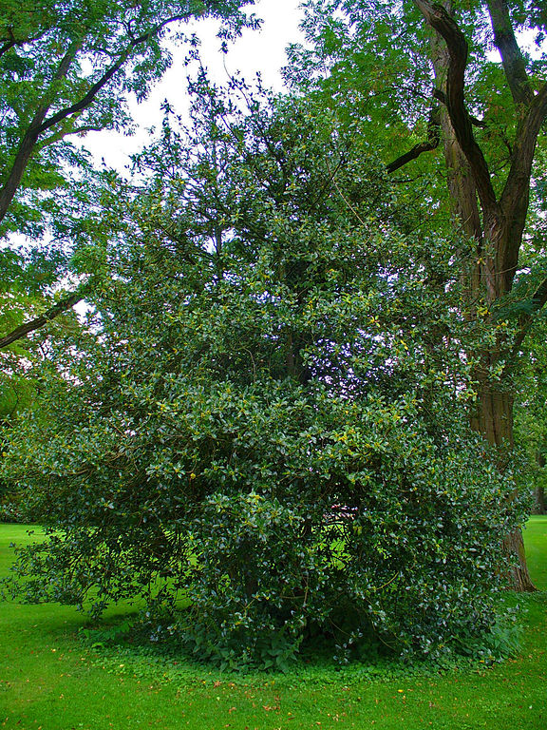

**Flowers and Fruit**

These trees are either male or female, with the female producing berries.

Flower

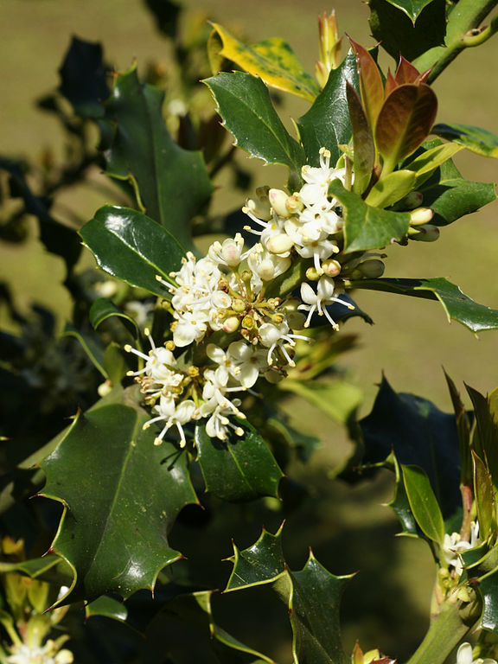

Fruit

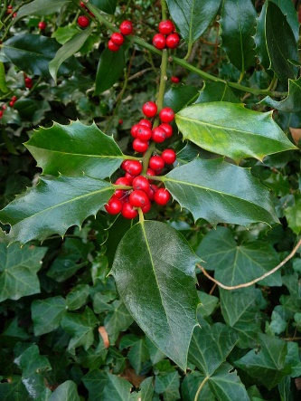

### **Bark**

Young bark is smooth and green, turning greyer with age.

Older Bark

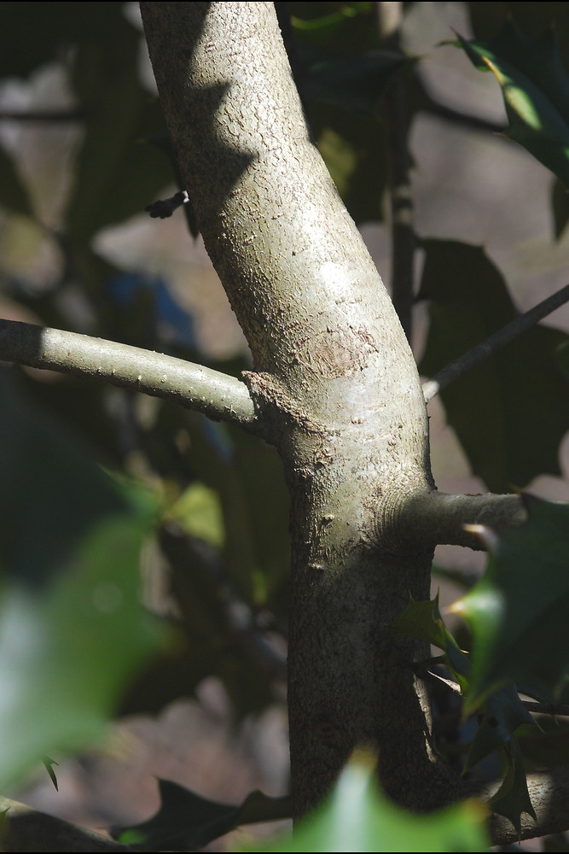

### **Leaves**

Holly trees are evergreen, their leaves are spiny.

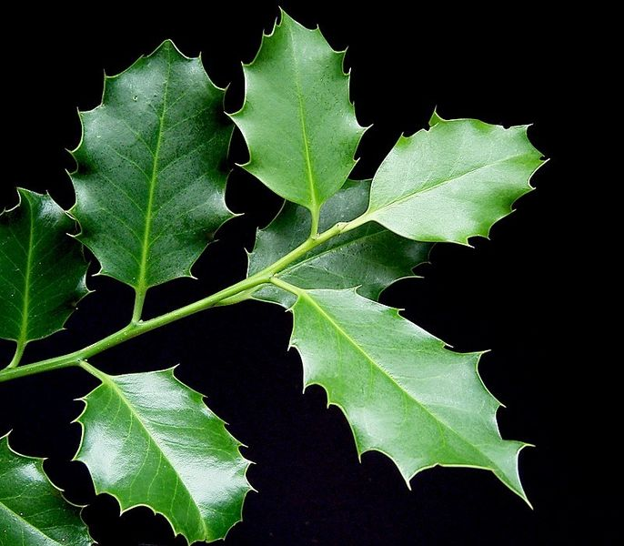

Botanical Illustration

